How to score

Goldin-meadow : gesturing makes memories that last

Cook, S. W., Yip, T. K., & Goldin-Meadow, S. (2010). Gesturing makes memories that last. Journal of memory and language, 63(4), 465-475.

Speech and gesture produced at all time points was transcribed and coded. Speech was transcribed verbatim, including filled pauses and hesitations. A particular vignette was considered recalled correctly on each of the memory tests if the speaker's description included the action and at least one other semantic element. For example, in the vignette portraying a man carrying a chicken to some scaffolding, if the participant said, “There was a man carrying a chicken and walking towards something,” the vignette was counted as recalled because the main event (the carrying action) was mentioned, along with two other semantic elements (the actor, man, and the patient, chicken). A vignette was not counted as recalled correctly if the semantic elements were recalled but their roles were reversed. For example, in the vignette portraying a dog sliding to the scooter, if the participant said, “The scooter was sliding to the dog,” the vignette was not counted as recalled correctly even though the dog, scooter, and sliding action were mentioned because the participant had incorrectly identified the dog as the endpoint of the sliding action and the scooter as the moving object. In addition, a particular vignette was not considered recalled correctly if novel items were added. For example, in the vignette portraying a train moving into a fenced corral, one of the participants incorrectly recalled it as a train crashing into a wall.

Conversational remembering : story recall with a peer versus fon an Experimenter

Hyman Jr, I. E. (1994). Conversational remembering: Story recall with a peer versus for an experimenter. Applied Cognitive Psychology, 8(1), 49-66.

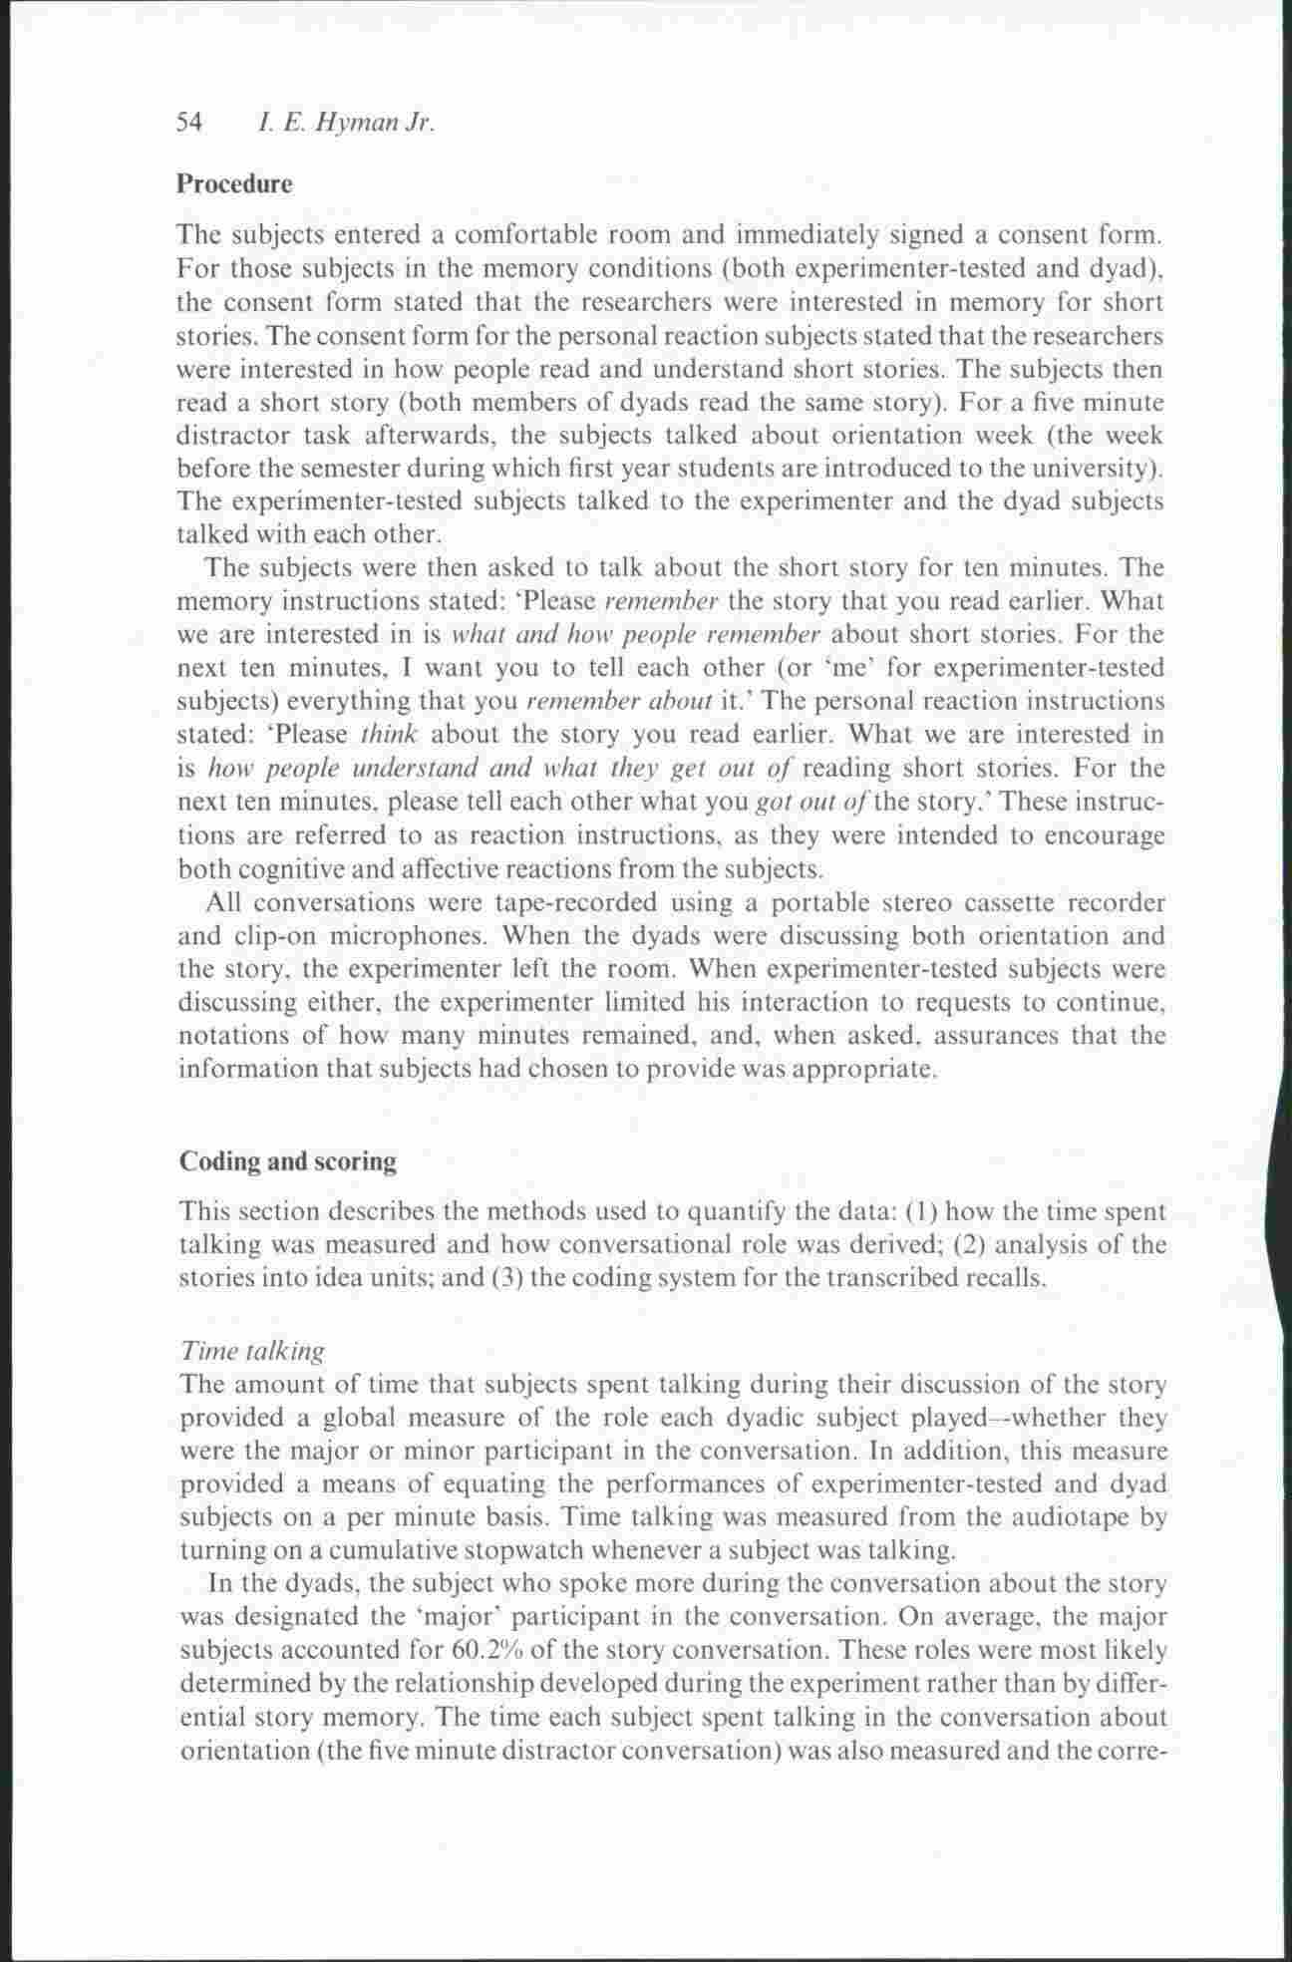
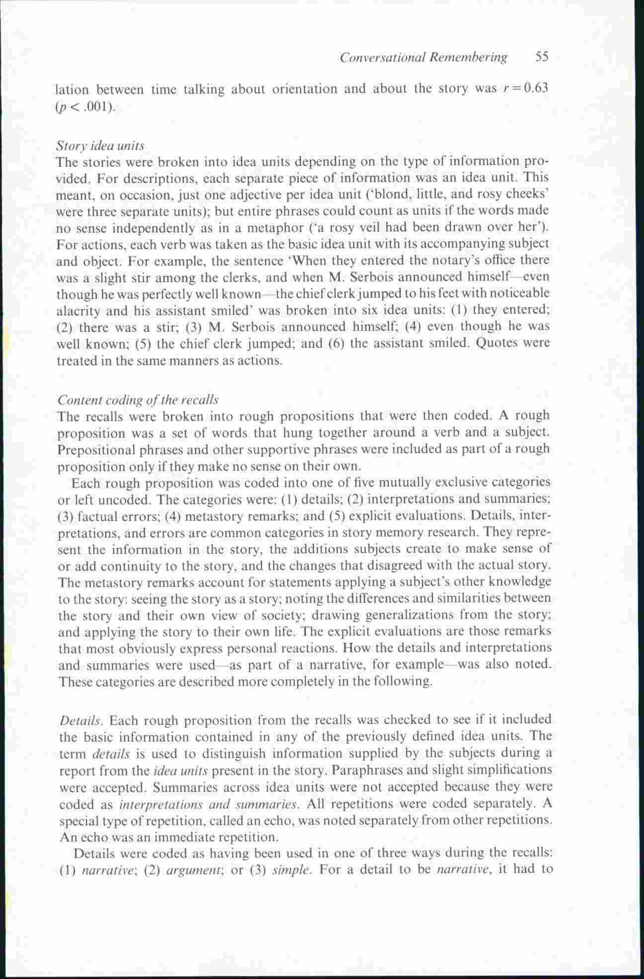
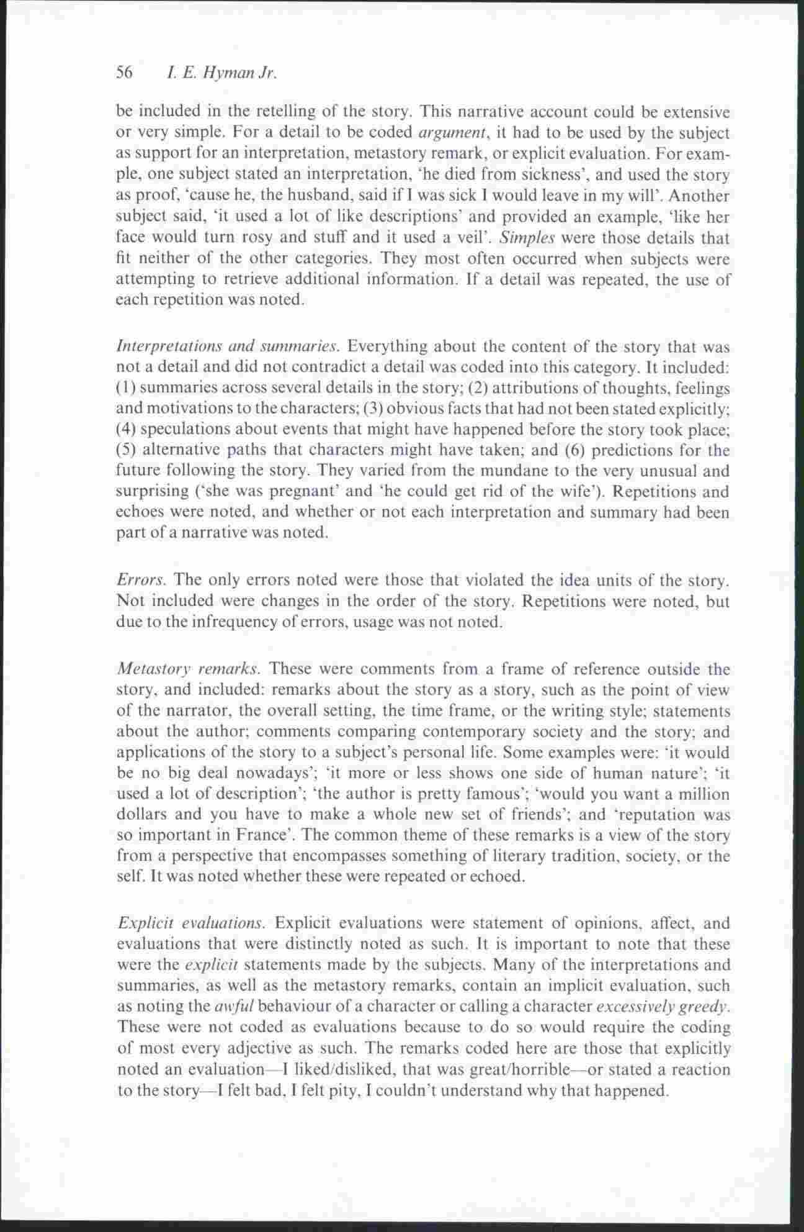
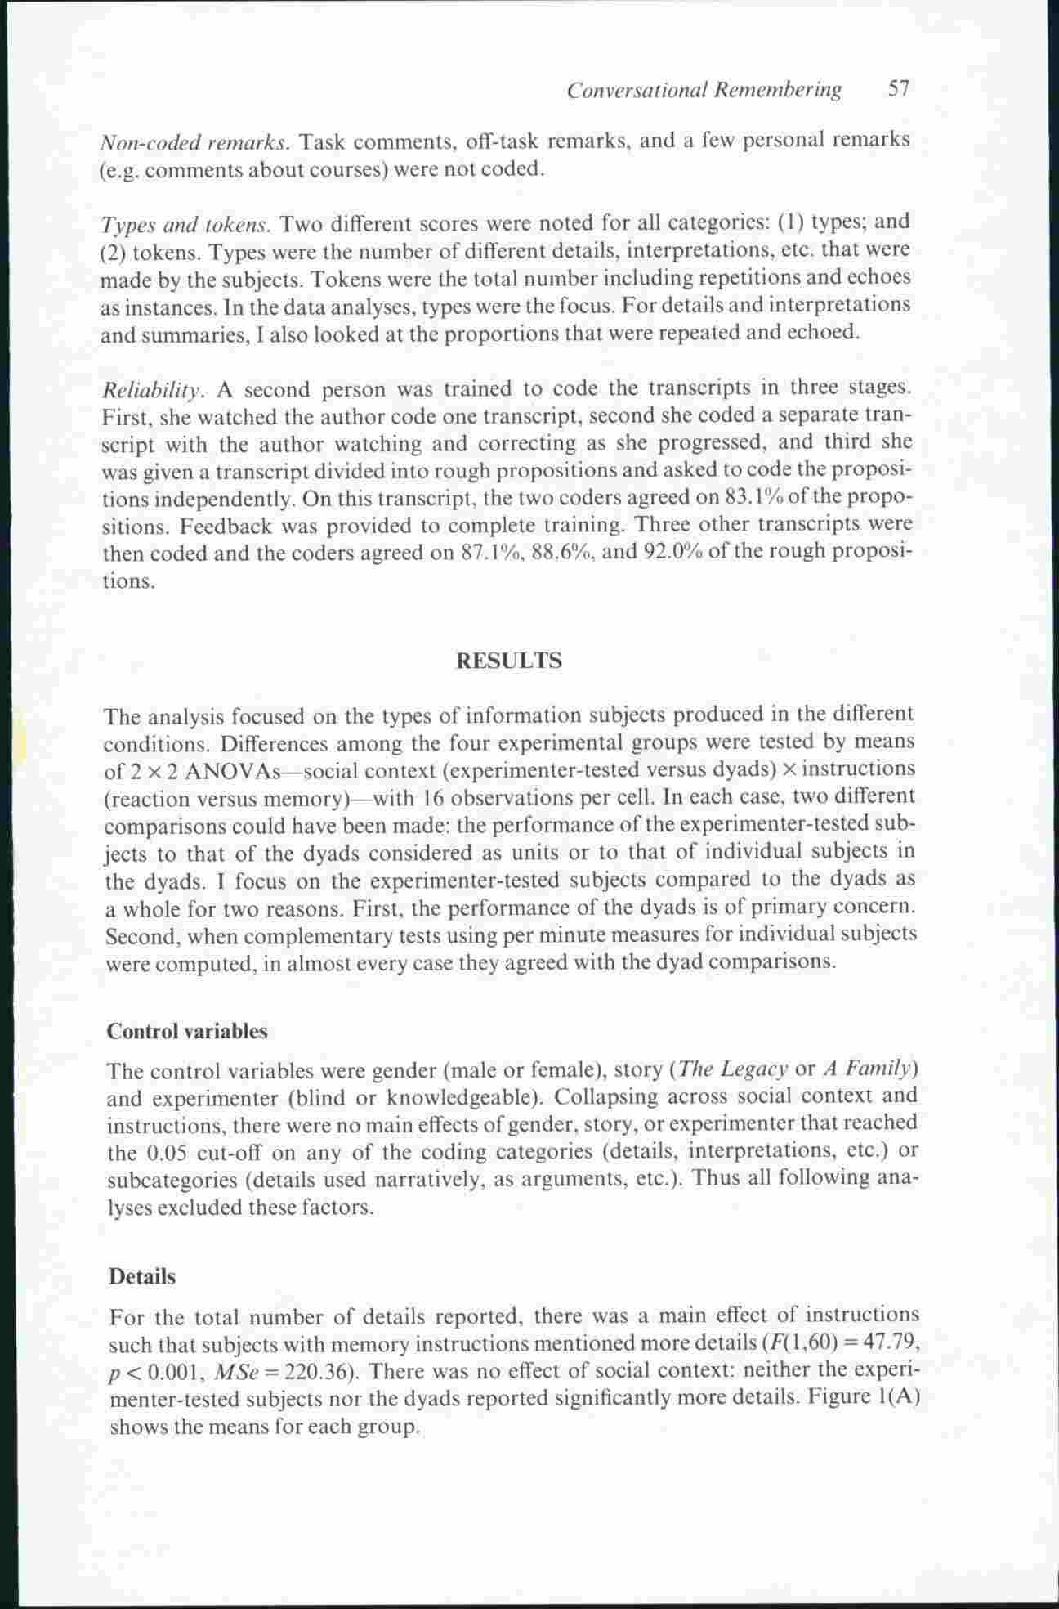

➔ A retenir : division du texte en ideas units
Les restitutions sont divisées en propositions. Ces propositions sont codées de 5 manières :

1) details
2) interpretations and summaries
3) factual errors
4) metastory remarks
5) explicit evaluations

Remembrance of Things Parsed: Story Structure and Recall
JEAN M. MANDLERANDNANCY S.JOHNSON Universi@ of Calz$ornia, San Diego

Design. Each subject recalled two stories. First one story was told and recall was tested after a lO-min unrelated visual recognition task. Then the other story was told and recall was tested 24 h later. Stories were counterbalanced across presentation order and each story was paired with each other story approximately equally often.
Procedure. Subjects were tested individually. They were told that the experimenter was interested in how people remember stories, that they would hear two stories and later be asked to tell them again as exactly as they could. Then the first story was played. Following a IO-min interpolated visual recognition task, subjects were asked to recall the first story. For the first- and fourth-grade subjects, the experimenter asked them to tell the story to another adult (with whom they were familiar) who was not present during the original telling. It was hoped that this procedure would reduce any tendency to summarize rather than recall. Instructions to all groups emphasized that verbatim recall was requested. Following the first recall, a few minutes were spent collecting age and other pertinent information about the subjects. Then the second story was played. The experimenter (or other adult) returned 24h later to collect the second recall dam. Both recalls were recorded and later transcribed.
Scoring procedures. The transcribed protocols were scored for presence or ab- sence of each proposition. Four scorers were used. Rather than using a mutual train- ing procedure designed to produce high interrater reliability, it was decided to use a double-criterion method. A strict criterion was used in which there was consensus that the recalled proposition expressed the meaning of the relevant proposition in the story. A loose criterion was used to include propositions about which there was disagree- ment among scorers.
Since we were interested in the structural characteristics of recall rather than the egocentric use of pronouns, we did not score a proposition as missing if it included the wrong pronoun. Misuse of pronouns was frequent in the first-grade protocols, in agree- ment with Piaget’s findings. Egocentric references were rare in fourth-grade and adult protocols.
The analyses included only those subjects who recalled at least one proposition from the story. In attempting to elicit recall, the experimenter referred only to “the story you just heard a few minutes ago” or “the last story you heard before I left yesterday.” This procedure was used because identifying stories by title or mention of the main character would have inflated recall of settings. If a child did not respond, probe questions were asked. These usually elicited partial recall of the story, but it seemed preferable not to include these data. Therefore, subjects were replaced if they did not spontaneously recall something from both stories. If the first-graders who did not recall anything were included and given scores of zero, the overall first-grade scores would, of course, be lower.
In addition to scoring presence or absence of the specified propositions, inversions of sequence of propositions within and between basic nodes and inversions of clauses within propositions were scored. Importations of new material (additions) were scored, and two kinds of elaborative clauses were scored for presence or absence: “temporal bridges” (e.g., when he got home) and “why clauses” (e.g., so it would not break into crumbs).

Social Context Effects on Story Recall in Older and Younger Women: Does the Listener Make a Difference?
Cynthia Adams,1 Malcolm C. Smith,2 Monisha Pasupathi,3 and Loretta Vitolo4
1University of Oregon, Eugene. 2University of Manitoba, Winnipeg, Canada. 3University of Utah, Salt Lake City. 4Eugene, Oregon.
Two narrative texts were used as the material to be learned and recalled. One was a contemporary children’s fable (Lo- bel, 1980), and the other was a modified version of a Sufi teaching tale (Shah, 1967). The two texts, representing two experimental conditions, differed in complexity. This al- lowed us to examine the robustness of our Age 􏰁 Listener prediction across different levels of story complexity. In addi- tion, we were able to examine whether tellers would simplify their retellings of the more complex story to a child listener.
The fable was a simple story about a wolf who disguised himself as a tree to trick a hen into coming outside her house. The text of the fable contained 284 words, 130 propositions, and 24 sentences, with an average of 11.8 words per sentence. The fable scored 2.6 on the Flesch-Kincaid in- dex, a rough index of text complexity (Schuyler, 1980). This index computes readability, or how easy a document is to understand, on the basis of the average number of syllables per word and the average number of words per sentence. It yields a score indicating a grade-school level; the lower the score, the easier the text is to read. The Sufi tale was an allegory about a stream on a journey in search of its identity. The text contained 473 words, 220 propositions, and 36 sentences, with an average of 13.1 words per sentence. The Sufi tale scored 5.2 on the Flesch- Kincaid index.
[…]
Coding Procedures
The oral story-retellings were transcribed from the audiotapes in preparation for scoring. Each recall protocol was then coded for propositional and elaborative content. In all cases, coders were unaware of the participant’s age and the listener condition. Each protocol also was analyzed for the proportion of main ideas relative to details included (i.e., a levels analysis, which was used as an indicator of recall coherence) and was given a complexity score (see below).
Propositional content.—Each recall protocol was first scored for the number of propositions present. Using a lenient criterion (Turner & Greene, 1977), we scored a proposition as correctly recalled if it represented the gist of a text- based proposition’s meaning. One trained individual coded the entire set of 95 protocols. To check the reliability of the propositional coding, a second trained individual coded a randomly selected sample of 28 protocols (14 for each story), representing 29% of the total number of protocols. There was 91.7% and 84.4% agreement achieved between the two coders on the fable and the Sufi tale, respectively. The first coder’s propositional scores were used in the data analysis.
In preparation for the levels analysis, Adams and Smith independently rated each proposition in the fable and the Sufi tale as representing one of four levels of importance (see Adams et al., 1997). First-level propositions were those that stated the main ideas of the story. Second-level proposi- tions were supporting statements of the main ideas. Third- level propositions were supporting details, and fourth-level propositions were inessential details. There was 91.7% agree- ment for the fable and 88.6% agreement for the Sufi tale. Differences in the ratings were resolved by consensus to provide a final set of levels for each story. For the fable, the resulting number of propositions for Levels 1 through 4 was 44, 40, 27, and 19, respectively. For the Sufi tale, the num- ber of propositions at each level was 50, 61, 58, and 51, re- spectively. Each proposition in the participants’ recall pro- tocols was then assigned to one of the four importance levels.
Elaborative content.—Once the text-based propositional coding was completed, the remaining recall content was coded for the number of elaborations present (broken down into propositional units using the criteria in Turner & Greene, 1977). Elaborations were defined as propositions generated by the teller during story recall that added to and extended the meaning of the original text base. These included pragmatic inferences, inferred psychological and physical attributes of characters, and inferred explanations for a char- acter’s behavior. Propositions that were completely unrelated to text-based content and/or were inaccurate were coded as errors (see Note 3). Because propositions that repeated either an original text-based proposition or a teller-generated elaboration were prevalent, and because the use of repetitions can create a rhythm that draws the listener into the story (L. F. Erz, professional storyteller, personal communi- cation, June 13, 1999), we included a category called repetitions in our coding.
One individual coded the entire set of protocols and a second individual coded 25% of the protocols (these were randomly selected). Percentage agreement between the two coders was 82.7. The first coder’s data set was used in the data analysis.
Complexity.—We used the Flesch-Kincaid readability score (Schuyler, 1980) as a rough index of the complexity of a retelling. As stated earlier, this index computes how easy a document is to understand on the basis of the average number of syllables per word and the average number of words per sentence. The lower the score (indicating a grade- school level), the easier the document is to understand. We applied the Flesch-Kincaid formula through the Microsoft Word 97 software package to each of the transcribed retell- ing protocols. Because this formula was originated for use with written, not oral, text and because it is based on relatively simple criteria (e.g., length of words), caution is war- ranted when interpreting individual complexity scores. How- ever, for group comparisons as a function of listener and story conditions, we have found this to be a useful and inter- esting, albeit rough, index of retelling complexity.

A code in the node : the use of a story schema in retrieval

Mandler, J. M. (1978). A code in the node: The use of a story schema in retrieval∗. Discourse Processes, 1(1), 14–35.doi:10.1080/01638537809544426

Scoring Procedures
The tape-recorded protocols were transcribed and then divided into propositions. Two criteria of recall of propositions were used. The first was a strict criterion (Category 1), in which two raters agreed that the essential meaning of a proposition had been reproduced. The second was a loose criterion and included two additional categories. Category 2 consisted of propositions which distorted the meaning of a proposition or which expressed only a subsidiary part such as a temporal clause, leaving out the main event being described. Propositions about which the raters disagreed as to whether the meaning had been adequately ex- pressed were also included in this category. Category 3 consisted of structural additions, i.e., propositions which filled the structural requirements of a node but consisted of unrelated or wrong material.
Additions, i.e., material which had not been included in the original stories were divided into two classes: reasonable additions and distortions. Reasonable additions included three types: (1) Redundancies, i.e., saying the same thing twice, often in a slightly different way. Redundancies appeared sometimes to be a kind of delaying action, the subject repeating something before retrieving the next proposition, and sometimes to insure that the experimenter understood what the subject meant. (2) Reasonable presuppositions, in which obviously inferable material was added to the original proposition. For example, in the Unlucky Day story (see Table 1), the Attempt might include the phrase "She retraced her steps" before continuing with the original proposition. (3) Exag- gerations, in which a statement was intensified in some way. For example, a storm which blew down some houses in one story was occasionally referred to as a terrible hurricane or a tornado. Although an attempt was made to separate these three kinds of reasonable additions, it was not always possible. A storm which blows down houses is apt to be a hurricane or a tornado and thus might be classed as a reasonable presupposition rather than an exaggeration. For statistical analyses the three types of reasonable additions were grouped into a single category.
Distortions included four types: (I) Repetitions of previously recalled nodes, in which other nodes were produced before the repetition. (2) Character and event confusions. These distortions consisted of importations from one episode into another, or from one node to another within the same episode. Typical ex- amples of character confusion were a single character being used as the protag- onist for both episodes or a character from one episode appearing in the other. In the Unlucky Day story, for example, Tom might help his sister find her money. An example of an event confusion would be Tom losing some money in- stead of or in addition to breaking his leg. (3) Irrelevant or wrong materialadded to a correctly recalled node. This type of addition was in marked contrast to reasonable presuppositions; although frequently related to the story line, it could not be assumed to be the case. For example, the subject might say "Tom broke his arm and had to go to the hospital," before continuing with the rest of the episode. (4) Structural additions. This category consisted of irrelevant or wrong material which was substituted for an entire node. For example, in the Unlucky Day story it might be recalled that the girl found her dollar. Not being able to retrieve the Ending, the subject might say, "She felt glad and went home."
As in the case of reasonable additions, there was some overlap among these categories and they were grouped into a single class for statistical analysis. For example, a structural addition might contain material from the other episode and thus represent a character or event confusion as well. In addition, there was partial overlap between the scoring of distortions and the loose criterion for propositions recalled. The loose criterion included all the structural additions and also included propositions in which major character or event distortions occurred. The general class of additions, on the other hand, included many rela- tively minor distortions. For example, the subject could correctly recall a propo- sition and yet add new or distorted material to it. In this case, a subject would be credited with correct recall and at the same time be scored as having made an addition.

Adult Age-Group Differences in Recall for the Literal and Interpretive Meanings of Narrative Text

Response Scoring
In preparation for coding, each retelling and interpreta- tion response was transcribed from the audiotape and assigned an arbitrary code so that coders would be unaware of the age and sex of the participant.
Retelling responses. — To assess recall for a story's liter- al text, retelling responses were checked against their respective text base for the presence of each proposition. Using a lenient criterion (see Turner & Greene, 1977), one coder scored the entire set of retellings. To check the relia- bility of the propositional analysis, a second coder scored a randomly drawn sample of 25% of the responses (six from each story). There was 87.34% agreement between the two coders.
To assess recall of the gist relative to the details in a story, the propositions in each text were rated for levels of importance by two of the authors. First-level propositions were those that stated the main ideas of the story. Second-level propositions were supporting statements of the main ideas. Third-level propositions were supporting details, and fourth-level propositions were inessential details. Differences in the ratings were resolved in confer- ence to provide a final set for each story. For the Stream story, the resulting number of propositions for Levels 1 through 4 was 46, 55, 44, and 49, respectively; for the Monk story, the number of propositions at each level was 42, 53, 50, and 43.
Interpretation responses. — To assess the deep and syn- thetic qualities of interpretive recall, we developed two 5-point rating scales, a depth scale and a synthesis scale, with 1 designating the low end of a scale and 5 designating the high end. The depth scale was designed to assess the extent to which an interpretation represented a deep covert meaning of a story. A low rating indicated a relatively shal- low or literal interpretation, one that remained tied to a story's propositional text base. A high rating indicated a
NARRATIVE RECALL P189
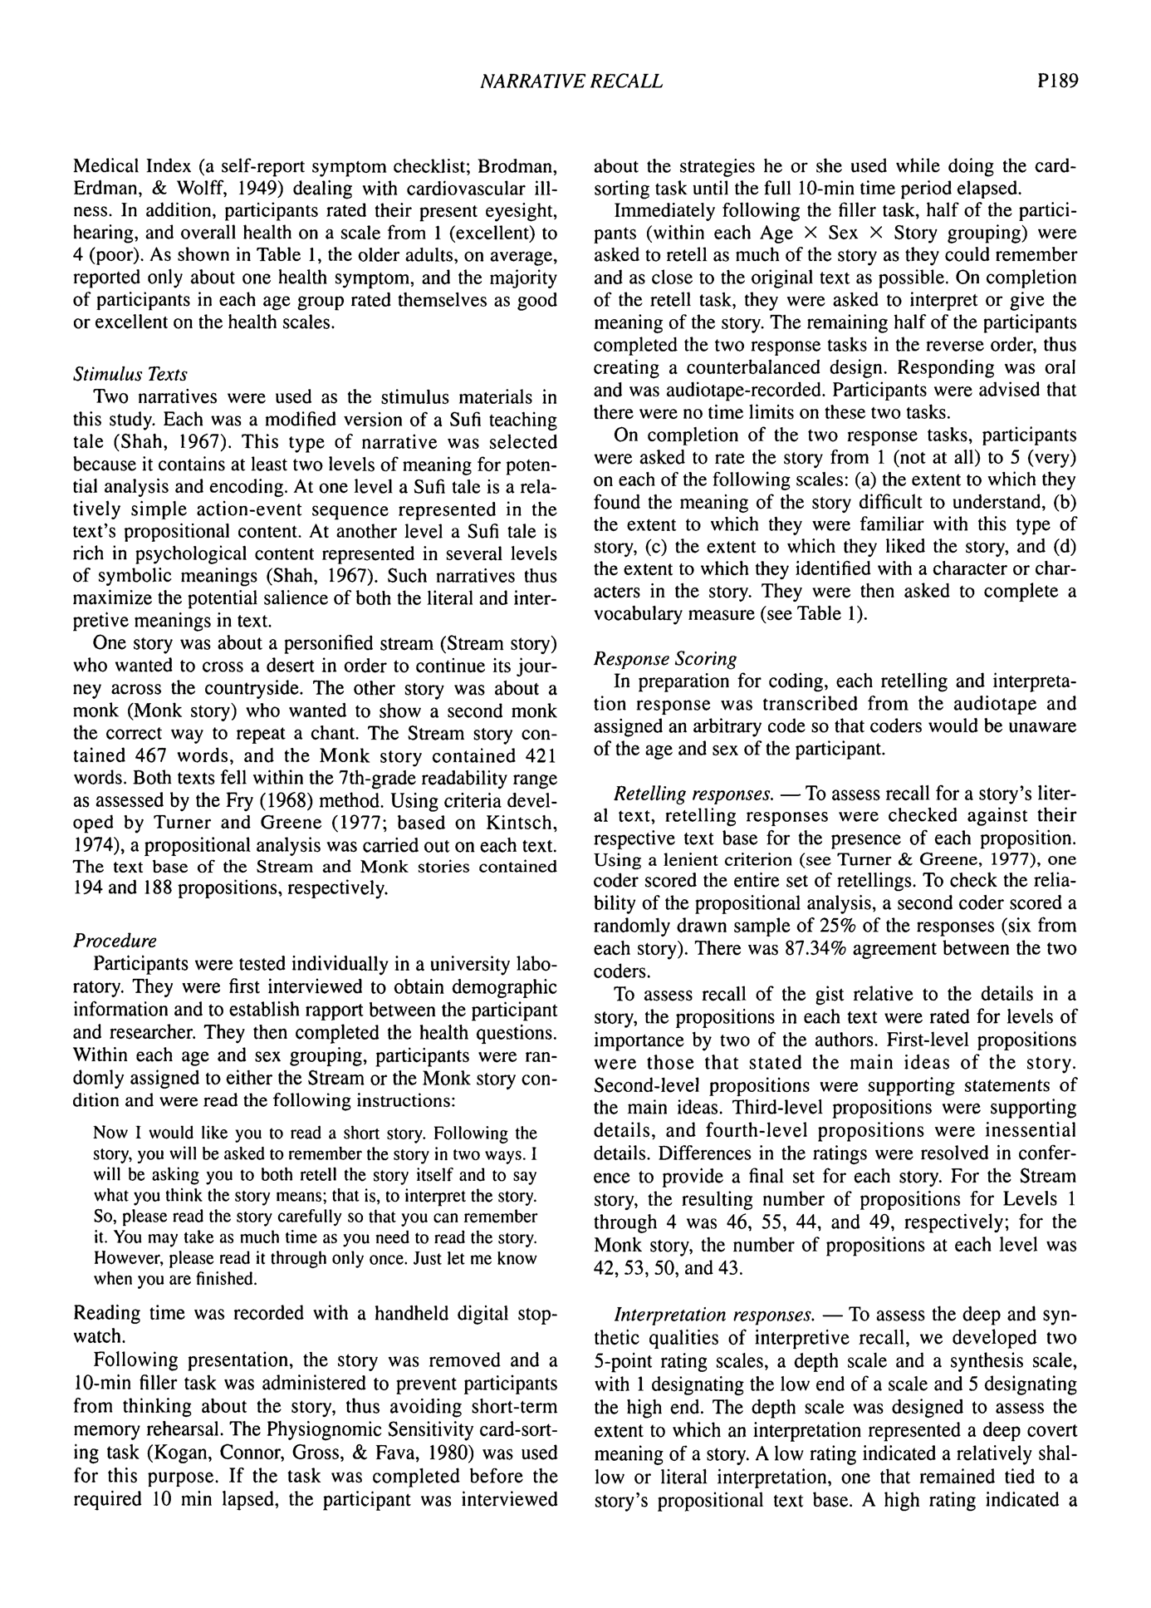deep or symbolic interpretation, one that went beyond the overt content and structure of the prepositional text to express the deep symbolic themes in the story. Following are examples of a shallow and deep interpretation of the Stream story:
Shallow interpretation (low on depth scale):
It seems like it's a story about cycles. It's a story about a stream that doubted that he could ever do something differ- ent and still be the same, still be a stream. And if there was nothing that could convince him that no matter what he did, if he just stayed that way, if he didn't try to change, to get by, then he wouldn't be able to be something more than a stream. And the stream realized that just because of a small change doesn't mean that he won't be a stream anymore. He'll still be a stream, but he'll still move and change and be better than just a swamp.
Deep interpretation (high on depth scale):
I think I see the story on three different levels. The first interpretation is that you have to be willing to be interdepen- dent. Be willing to work with people, and not stand alone. 'Cause if you stand alone, then you are alone and you don't get, you don't prosper as much, and you don't feel the good feelings that you get out of being with people. The second thing is that you have to be willing to accept change. You can't be rigid and set into your own created set of values and principles. And your knowledge, you have to be willing to change with the changes the circumstances require. And then the third is sort of a synthesis of the two. That you make change most easily and effectively if you work with people. That you don't need to make change on your own.
The synthesis scale was designed to assess the extent to which an interpretation represented a complete and inte- grated whole. A low rating indicated an analytic response, or one in which the focus of the interpretation was on delin- eation, explanation, and/or illustration of the individual concepts or symbols in a story. A high rating indicated a more integrated response in which the symbolic elements of a story were unified into a succinct and complete whole. Synthetic responses were conceptually dense, abstract, and holistic. Following are examples of an analytic and a syn- thetic interpretation of the Stream story:
Analytic interpretation (low on synthesis scale):
I would interpret the story to be a representation of how a person would deal with a barrier or problem put in front of him. The barrier being the desert and the person's life being the stream. And the wind would be religion or faith in some- thing as a means of overcoming that barrier to achieve what your objective is.
Synthetic interpretation (high on synthesis scale):
The story is kind of a parable. It is intended to set the tone for awakening people to aspects of their personality which they had not been aware of in the past. The parable indicates that maybe an outsider can make suggestions about a per- son's own character which will awaken that person to some strengths which he didn't know he had and can suggest ways of using those parts of his character in conjunction with other things in his environment to overcome difficulties. And in the end, the person who is having difficulty becomes aware, number one, of additional strengths and, number two,
of the fact that he can use his environment to carry himself forward.
Note that although the above analytic example is rela- tively short, by its very nature the analytic approach to the task was expected to produce lengthier interpretations than those produced by the more integrated synthetic approach. Length was therefore expected to be negatively correlated with the ratings on the synthesis scale. Length was not, however, a necessary condition for an analytic response and was therefore not a defining feature for the coders to use when rating interpretations on the synthesis scale.
Nine coders were trained to score the interpretation responses. Training procedures were adapted from those developed by White (1985) for use in the "holistic" scoring of answers to essay questions used in tests constructed by the Educational Testing Service. All coders were brought together at the same time and place for training as well as for coding. At the first session, coders read through the entire set of protocols to become familiar with the data. At the second session, a coding criteria guide was introduced, and coders were asked to read through the set of protocols a second time, keeping the scoring criteria in mind while reading. The coding guide gave a general definition of each criterion as well as a description of the specific features that defined end- and midpoints on the two scales. At the third session, sample protocols were distributed, independently coded, and discussed. This series of controlled readings served two purposes: (a) to ensure that all coders were familiar with, and had deeply processed, the criteria prior to coding, and (b) to facilitate a sense of community among the coders which, according to White, is essential to the success of this type of coding.
The final coding was also conducted in group sessions, with a separate session designated for each story. Within each session, three or four coders were assigned to each of the two rating scales. Once assigned, each coder worked independently until he or she completed the entire set of response protocols. These group coding sessions not only eliminated possible extraneous factors in the scoring proce- dure but also served to further enhance the sense of com- munity among the coders.
Interrater reliabilities were assessed using Cronbach's alpha. The alpha coefficients for the Stream story were .88 for depth and .84 for synthesis. For the Monk story, alphas were .77 for depth and .89 for synthesis.

Que faire pour les mots avec adjectifs ? Si les gens disent juste chinois, on compte bons ? pareil s’ils disent juste écolo au lieu de militants écologistes ?

Pour tester la working memory, on pourrait faire une tâche de n back ?

Si on veut tester leur mémoire, il faut leur faire faire une tâche de distraction entre la fin de l’histoire et le rappel non ? on voit souvent ça dans les articles, ça évite peut-être l’effet de récence ?

Pour vérifier la complexité narrative des sujets (mais c’est pour les enfants) :

Observing Storytellers Who Use Rhythmic Beat Gestures Improves Children's Narrative Discourse Performance
Vilà-Giménez, I., Igualada, A., & Prieto, P. (2018). Observing storytellers who use rhythmic beat gestures improves children’s narrative discourse performance. Developmental psychology

‘To obtain a measure of overall narrative structure, we used a modified version of the coding system applied by Demir et al. (2014) and Demir et al. (2015a),10 which in turn is based on Stein and Glenn’s (1979) approach to narrative structure in children. According to this approach, the organizational quality of a child’s narrative can be measured in terms of four main features, namely the presence of an animate protagonist, temporal structure, causal structure, and goal-directed action. Each feature is considered to be a prerequisite for the next, and thus narratives with more of these features are rated more complex than stories with fewer of them. The rubric we used to score the narratives produced by child participants is shown in figure 6. A child’s narrative was rated as a “complete goal-based narrative” and received the highest score if it showed signs of causal and temporal structuring and specified the initiating event or challenge facing the protagonist, his/her consequent goal, how he/she attempted to achieve the goal, and the eventual outcome of that attempt. It should be noted that in retelling the
cartoons children occasionally remembered that some object or animal had been involved but could not quite remember which one. In such cases, we counted this as a successful retelling only if the object they named was similar in kind to the object in the cartoon—for example, if the child referred to the mouse as a “squirrel”. An example of a scored narrative can be seen in Appendix C.
Score | Features of the narrative
0 | A narrative with no structure. It does not even contain a descriptive sequence; the story is not remembered.
1 | A descriptive sequence. This is a narrative that includes the physical and personality characteristics of an animate protagonist with no mention of a sequence of actions (i.e., no temporal structure).
2 | An action sequence. This is a narrative with actions described in a temporal order (actions follow one another in time) but in which the actions are not causally organized (i.e., if there was one event causing the following event or events, the story was categorized as an action sequence).
3 | A reactive sequence. This contains actions that are temporally and causally organized but does not include either the protagonist’s goal11 or the attempt to achieve the goal or neither of the two. The outcome is always mentioned here.
4 | An incomplete goal-based narrative. This includes temporal and causal structure, a goal statement and/or description of an attempt to achieve the goal, but no information about the outcome.
5 | A goal-based narrative. This includes not only temporal and causal structure as well as a goal statement, description of an attempt to achieve the goal, and the final outcome.
6 | A complete goal-based narrative. This contains not only temporal and causal structure but also all the main features noted above. Moreover, the story is fleshed out with details including the initiating event.
Figure 6. Rubric for scoring of child-produced retelling narratives (based on Demir et al., 2014, and Demir et al., 2015a) ‘

